Infosys Springboard Virtual Internship

“Project Name: Automated Python Docstring Generator”

Milestone 2: - AST-Based parsing with Synthesis & Validation

Name: Shreya BJ
Date: 22 January 2026

Milestone 2: - Docstring generation with Synthesis and Validation

Introduction

While Milestone 1 focused on identifying missing docstrings and analyzing Python code structure, Milestone 2 advances the system into a complete documentation synthesis and quality-assurance pipeline. This phase emphasizes not only the presence of docstrings, but also their completeness, consistency, and compliance with Python documentation standards.

The Automated Python Docstring Generator & Validator is extended to automatically generate explanatory docstrings, support multiple industry-standard documentation styles, and validate generated documentation against PEP 257. By combining AST-based static analysis with deterministic, rule-based logic, the system ensures documentation quality without relying on cloud-hosted or generative AI models.
This milestone bridges the gap between basic documentation detection and professional documentation enforcement, aligning the tool with real-world Python development practices.

Objectives
The main objectives achieved in this milestone are:

1. Extended Docstring Generation
- Automatically generated docstrings for undocumented functions, methods, and classes.
- Produced explanatory, rule-based summaries inferred from function names, parameters, and control structures.
- Inserted generated docstrings directly into the source code at correct locations

2. Multi-Style Documentation Support
- Implemented support for the following documentation standards:
  - Google Style
  - NumPy Style
  - reStructuredText (reST)
- Ensured the same semantic information is rendered according to the selected style format.

3. Improved Docstring Completeness
- Enhanced generated docstrings with additional sections:
  - Raises – detected from raise statements.
  - Yields – detected for generator functions.
  - Attributes – extracted from class-level variables.
- Ensured all relevant documentation sections are present where applicable.

4. Docstring Validation & Compliance
- Validated uploaded Python source code against PEP 257 using pydocstyle and generated a detailed compliance report..
- Enforced PEP 257 rules for:
  - Correct placement
  - Formatting
  - Structural consistency
- Clearly indicated compliance status as PASS or WARN.

5. Coverage & Compliance Reporting
- Generated file-level documentation reports including:
  - Total functions and classes detected
  - Documented vs undocumented elements
  - Documentation coverage percentage (post-generation)
  - PEP 257 compliance status
- Computed documentation coverage based on generated docstrings and reported compliance of the uploaded code against PEP 257.

6. Enhanced User Interface
- Extended the Streamlit frontend with:
  - Tab-based navigation (Code, Generated Docstrings, Validation, Analysis)
  - Coverage and compliance metrics
  - Section-wise breakdown of documentation analysis
- Provided clear visual feedback for documentation quality.

Code Implementation
The project is implemented entirely in Python and is divided into logical components for clarity and scalability.

Module 1: AST Parser & Analyzer
This module continues to use Python’s AST library for static code analysis and has been enhanced to extract richer metadata. In addition to identifying modules, classes, functions, and methods, it now detects:
- Raised exceptions
- Generator functions using yield
- Class attributes
- Source code line ranges
This enables deeper understanding of code behaviour while maintaining safe, non-executing analysis.

Module 2: Docstring Synthesis Engine
This module extends baseline docstring creation into rule-based explanatory generation. Using naming conventions, argument lists, and control-flow cues, the system generates meaningful summary lines and structured documentation sections.
The synthesis engine dynamically adapts output to Google, NumPy, or reST formats, ensuring consistency with industry documentation practices.

Module 3: Docstring Validation & Compliance Engine
This component integrates pydocstyle to validate generated docstrings against PEP 257. Validation is performed on the post-generation code, ensuring that inserted docstrings meet Python’s official documentation standards.
The module flags formatting and structural violations and produces a clear compliance status for reporting.

Module 4: Coverage & Reporting Engine
A dedicated reporting layer computes documentation metrics after generation, including coverage percentage and compliance state. This transforms the tool from a generator into a documentation quality measurement system, suitable for continuous improvement workflows.

Module 5: Streamlit Frontend
The Streamlit frontend has been enhanced to support Milestone 2 objectives through improved visualization and interaction. Users can upload Python files, select documentation styles, view generated docstrings, inspect validation results, and analyse documentation coverage—all within a single interface.
This ensures accessibility for beginners while providing sufficient depth for technical evaluation.
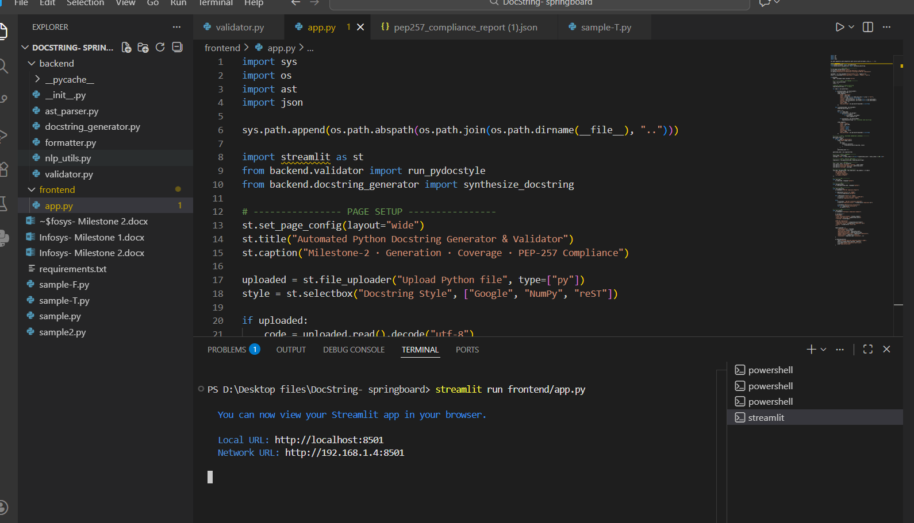

Output Screenshots:
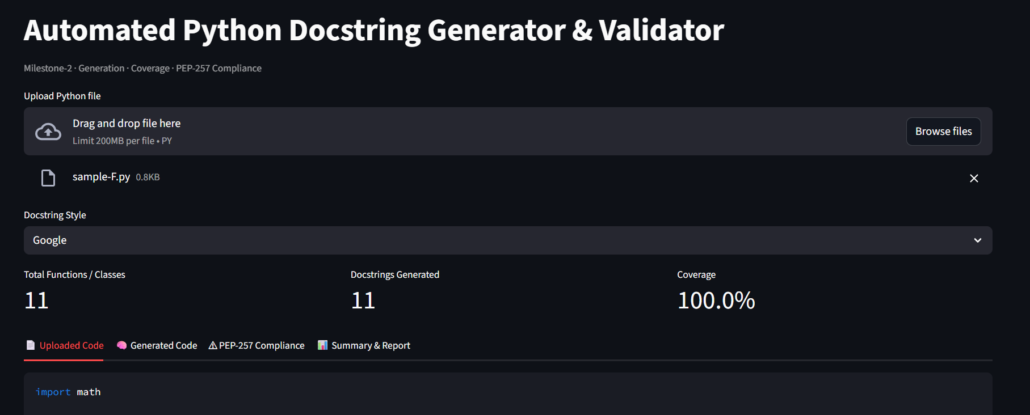

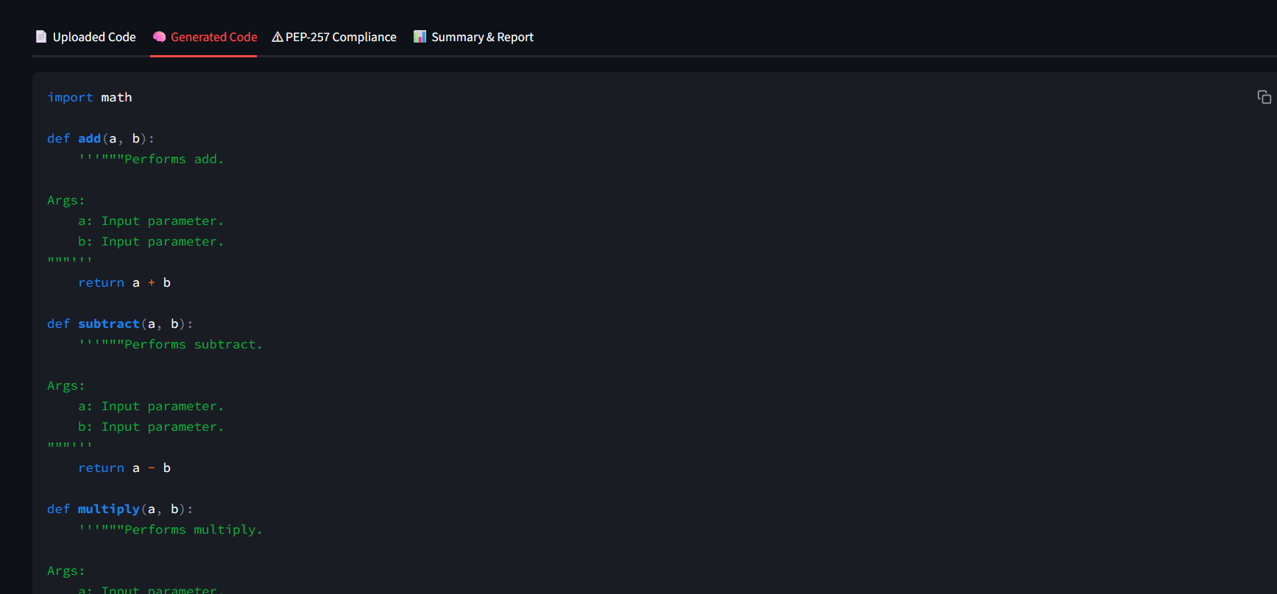
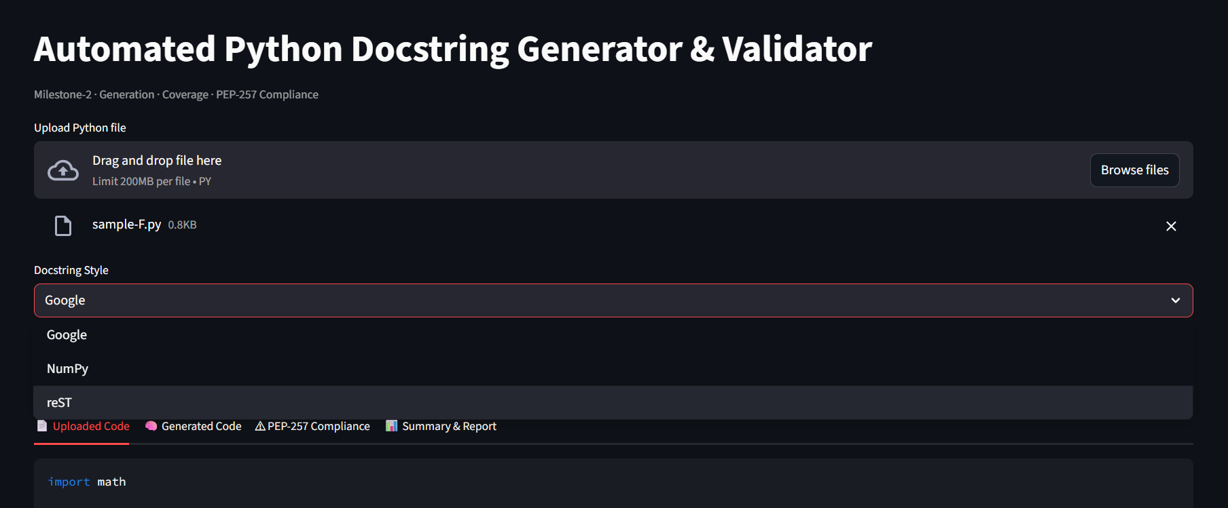
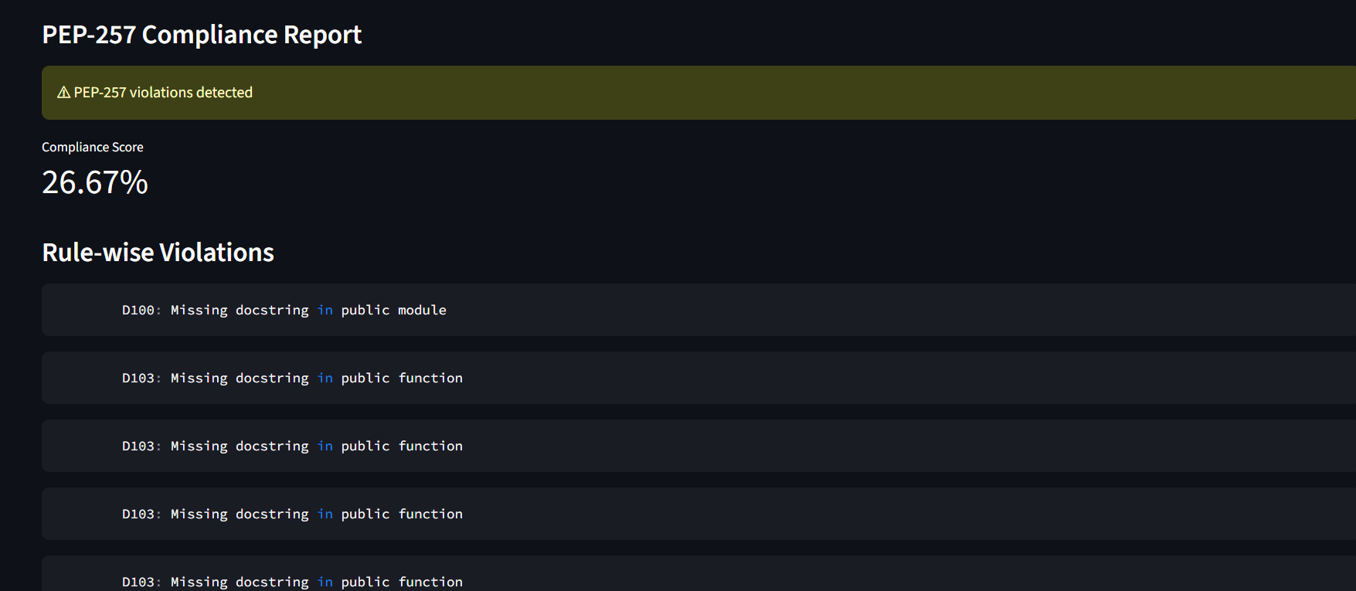

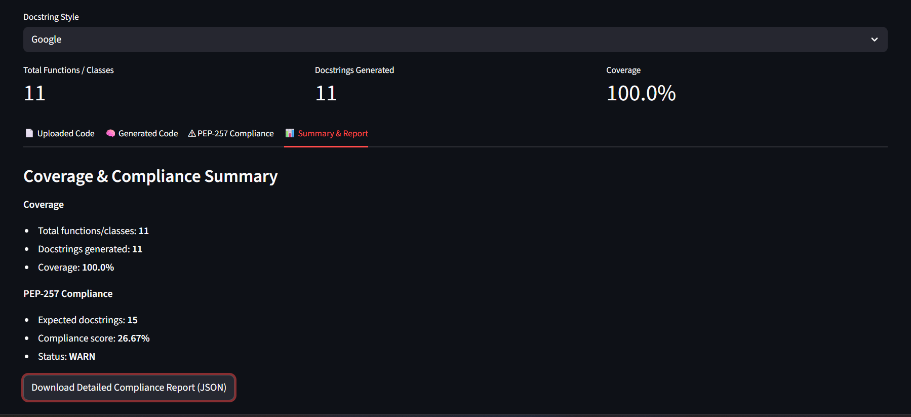

Conclusion

In this milestone, we successfully implemented a complete docstring synthesis, validation, and quality-assessment pipeline for Python source code. The system accurately analyzes Python programs using AST-based static analysis, automatically generates explanatory docstrings for undocumented code elements, and validates documentation quality against PEP-257 standards.

Key achievements of this milestone include:

- Automated generation of docstrings for functions, methods, and classes using rule-based synthesis.
- Support for multiple industry-standard documentation styles, including Google, NumPy, and reStructuredText (reST).
- Enhanced docstring completeness through detection of Raises, Yields, and class Attributes.
- Robust validation of uploaded Python files using pydocstyle, with clear identification of PEP-257 violations and compliance status.
- Accurate separation of documentation coverage and standards compliance, enabling meaningful quality assessment.

The integration of an enhanced Streamlit-based frontend significantly improves usability by allowing users to upload Python files, select documentation styles, view generated docstrings, inspect PEP-257 compliance reports, and analyze coverage metrics within a single interface. This makes the tool accessible to beginners while remaining technically rigorous for advanced users.
Overall, Milestone 2 transforms the project from a detection-based utility into a practical documentation quality enforcement system. The modular and scalable architecture ensures extensibility for future enhancements such as automated docstring insertion into repositories, CI/CD integration, and continuous documentation quality monitoring. The project demonstrates effective application of AST parsing and rule-based NLP techniques in real-world software engineering, aligning closely with industry documentation standards and best practices.

